**Database Management Project**

**Deliverable 0: Project Proposal (Initial Setup)**

Kishan Ishwarbhai Patel

**Written Proposal for Computer Store Management System**

**Purpose for the Database**

The Computer Store Management System is designed to manage product inventory, track customer purchases, details of suppliers and order details. Its main purpose is to precise stock monitoring, simplifies the order processing workflow, and improves supplier coordination. Moreover, it enhances customer relationship management by storing purchase histories and customer information.

**Key functionalities**

* Inventory Management: Monitor stock levels, organize product categories, and automate the restocking process with suppliers.
* Order Processing: Oversee customer orders and document purchases.
* Supplier Management: Keep supplier information on file and track products being received.
* Customer Management: Manage customer profiles, including their purchase history and contact details.
* Reporting: Produce reports on sales, inventory, and suppliers to gain business insights.

**Entities included in the Database**

1. **Products:**
   1. Product ID (Primary Key)
   2. Product Name
   3. Brand
   4. Price
   5. Stock Level
   6. Supplier ID(Foreign Key)
   7. Category ID(Foreign Key)
   8. Warranty Period
   9. Product Model/Serial Number
   10. Specification
2. **Suppliers:**
   1. Supplier ID (Primary Key)
   2. Name of the Supplier
   3. Phone
   4. Email
   5. Address
   6. Payment Terms
   7. Contact of Person
3. **Customers:**
   1. Customer ID(Primary Key)
   2. Customer First Name
   3. Customer Last Name
   4. Phone
   5. Email
   6. Address
   7. Customer Type( Business, Organization or Individual)
   8. Company Name
4. **Orders:**
   1. Order ID (Primary Key)
   2. Customer ID (Foreign key)
   3. Order Date
   4. Product ID(Foreign key)
   5. Online Order (Yes or No)
   6. Store Order (Yes or No)
   7. Total Amount
   8. Quantity
   9. Order Status( Pending, Completed, Shipped)
   10. Delivery date(Expected delivery date)
   11. Payment Status(Paid, Pending, failed)
5. **Employees:**
   1. Employee ID
   2. First Name
   3. Last Name
   4. Position
   5. Salary
   6. Employee Role
   7. Department
6. Categories:
   1. Category ID(Primary Key)
   2. Category Name
   3. Description
   4. Main Category
7. Payments:
   1. Payment ID(Primary Key)
   2. Order ID(Foreign key)
   3. Payment method
   4. Payment Status
   5. Payment Date
   6. Transaction ID
   7. Total Amount
8. Returns:
   1. Return ID(Primary Key)
   2. Product ID(Foreign key)
   3. Order ID(Foreign key)
   4. Return Date
   5. Reason for Return
   6. Refund Amount
9. Shipping:
   1. Shipping ID(Primary key)
   2. Order ID(Foreign Key)
   3. Shipping Method
   4. Shipping Date
   5. Delivery Status
   6. Tracking Number
   7. Carrier
10. Repairs:
    1. Repair ID(Primary key)
    2. Product ID(Foreign Key)
    3. Customer ID(Foreign Key)
    4. Issue Description
    5. Repair Start Date
    6. Repair End Date
    7. Employee ID(Foreign Key)
    8. Repair Status(Pending, In-Progress, completed, returned without repaid)
    9. Cost
    10. Warranty Claim(Yes/No)
11. Order Details:
    1. OrderDetailsID(Primary key)
    2. Order ID(Foreign Key)
    3. Product ID(Foreign Key)
    4. Quantity
    5. Unit Price
    6. Discount
    7. Tax
    8. Total Price

**Types of Reports**

* Monthly Sales Reports
* Inventory Reports
* Customer Purchase History
* Suppliers Orders List
* Profit Margin Report

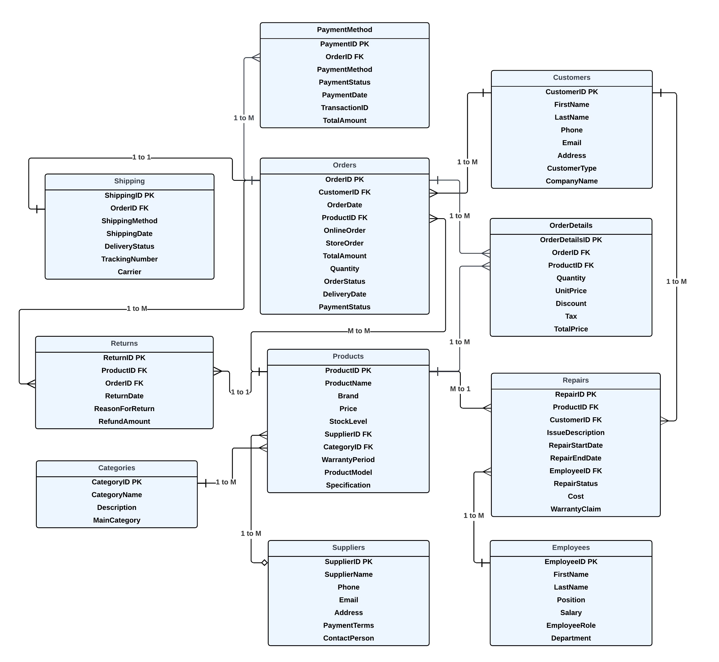**Relationship Diagram**